Overview of the MPEG-4 Standard

This chapter provides an overview of the MPEG-4 standard. It employs arbitrary shape coding techniques which I find noteworthy for future improvements on shape-adaptive coding. Readers are encouraged to read this chapter at their own discretion. Error resilience support of MPEG-4 is not discussed in this chapter since this issue is related to transmission errors and network environment and they are out of the scope of my thesis.
Coding of video object which includes irregular-shaped regions of a video scene is first introduced to this standard. Also, independent coding of foreground and background objects in a video scene is enabled.

Coding of Objects with Arbitrary Shapes
MPEG-4 supports the coding of multiple Video Object Planes (VOPs) which are images of arbitrary shape corresponding to different objects. The object hierarchy within MPEG-4 is illustrated below:
Video Object Planes (VOP): images of arbitrary shape
Group of VOPs (GOV)
Video Object Layer (VOL)
Video Object (VO): set of VOLs
Visual Object Sequence (VS): Sequence of VOs
The alpha map is used to indicate which pixels belong to the VOP1 (the character) as shown in Fig. 9.1 and help position it within the frame Error: Reference source not found.
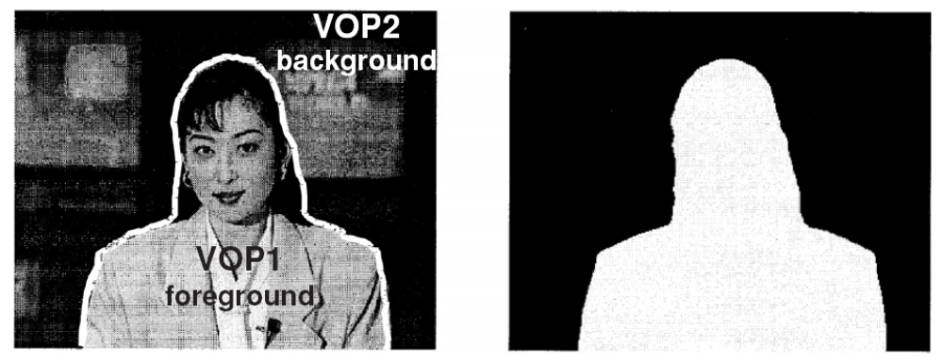
Fig. 9.1 Segmented Akiyo sequence with binary alpha map indicating shape and position of VOP1 Error: Reference source not found .

MPEG-4 adapts shape-adaptive macroblock grid which is a rectangular window with size multiple of 16 in each direction is used to enclose VOP and to specify the location of macroblocks within it Error: Reference source not found.
The coding of VOPs includes (1) adaptive shape coding, and (2) texture coding Error: Reference source not found.

Shape Coding
MPEG-4 supports two types of shape coding: (1) binary alpha map coding (for opaque VOPs) and (2) gray-scale alpha map coding (for VOPs with varying transparencies).
There are 3 types of binary shape coding techniques Error: Reference source not found. Block-based coding and contour-based coding both code the shape explicitly while chroma keying method encodes shape of VOP implicitly and it does not require an alpha map.
- Block-based coding: The shape-adaptive macroblock is superimposed on the alpha map and each macroblock is labeled as a Binary Alpha Block (BAB). There are three types of BAB:
- those that lie completely inside the VOP,
- those that lie completely outside the VOP, and
- those that like at boundaries (boundary/contour BABs).
Only for boundary BABs, the shape information needs to be encoded explicitly because these BABs contain some opaque and some transparent pixels. For case (a) and (b), the shape does not need to be explicitly coded since these contain either all opaque or all transparent pixels and it is enough to signal this using BAB type. There are two different block-based shape coding techniques: context-based arithmetic encoding (CAE) and Modified Modified READ (MMR) coding.
When boundary BABs are processed using CAE, a template of 10 causal pixels, as shown in Fig. 9.2, is used to define the context for predicting the shape value of the current pixel. Two exceptions are defined when the current pixel locates in the top two rows or left two columns or two right rows. When the current pixel locates in the top two rows or left two columns, context pixels from the BABs to the top and left are used. This is an instance when some pixels of the BAB use context pixels from other BABs. When the current pixel locates in the two right rows, context pixels outside the BAB are undefined. These context pixels are instead replaced by the value of their closest neighbor from within the current BAB.
For intercoding of shape information, a context of nine pixels was defined for intercoding as shown in Fig. 9.3. Intercoding could be used to further exploit temporal redundancies in VOP shapes. In the figure, we can see that four pixels from the previous frame are used as contexts. These pixels form previous frame are specified and given by the corresponding shape motion vector (mv_{y}, mv_{x}). It is up to the decoder to decide whether or not to encode any prediction residue bits and to reconstruct the VOP using only the shape information from previously decoded versions of the VOP. The BABs may be subsampled by a factor of 2 or 4 to enhance coding efficiency before performing intracoding or intercoding of shape information.
Modified Modified READ (MMR) shape coding is a technique that encodes the BAB as a bitmap. Binary data is encod3ed line by line and only the positions of changing pixels where the data change from black to white or vice versa are encoded for each line of data. Similar to CAE, MMR codes are only used for boundary BABs.
From Error: Reference source not found, the authors find that the CAE coder outperformed the MMR coder for both intra- and intercoding of shape in both lossless and lossy modes.
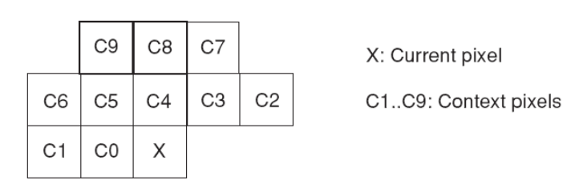
Fig. 9.2 Context pixels for intracoding of shape Error: Reference source not found.
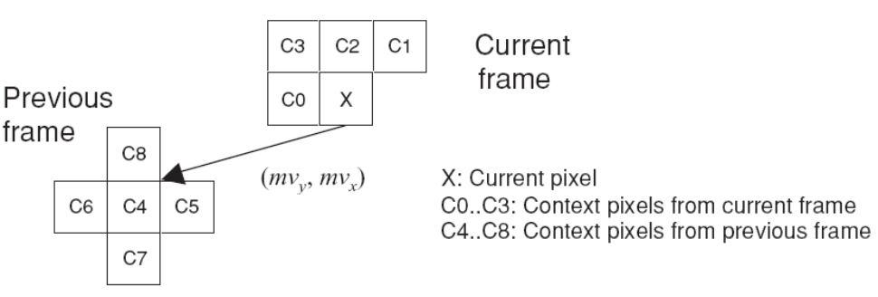
Fig. 9.3 Context pixels for intercoding of shape Error: Reference source not found.

- Contour-based coding: this type of coding method is used to encode the contour describing the shape of the VOP boundary. There are two contour-based shape coding techniques: (1) vertex-based shape coding and (2) baseline-based shape coding.
Vertex-based shape coding uses a polygonal approximation to represent the outline of the shape. Selecting appropriate vertices for polygon is crucial because the placement of the vertices of the can significantly affect the shape approximation error. An iterative approximation scheme is employed. Wherever the distance between the original shape exceed a given threshold, a new vertex is inserted [X1]. Example steps of iterative shape approximation using polygon is shown in Fig. 9.4. Only the positions of the vertices need to be recorded and transmitted to the decoder, and chain coding is used to encode them. An example of this process is shown in Fig. 9.5. We note that the shape is represented as a chain of vertices and each direction is assigned a number. These numbers then form a sequence describing the traversing of the vertices in a clockwise manner. The chain coded result may then be differentially coded.
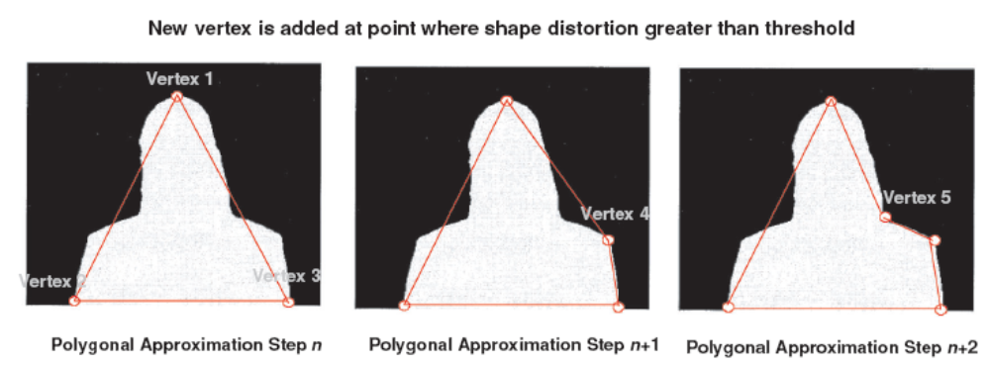
Fig. 9.4 Iterative shape approximation using polygons. Wherever the error exceeds the threshold, a new vertex is inserted Error: Reference source not found.
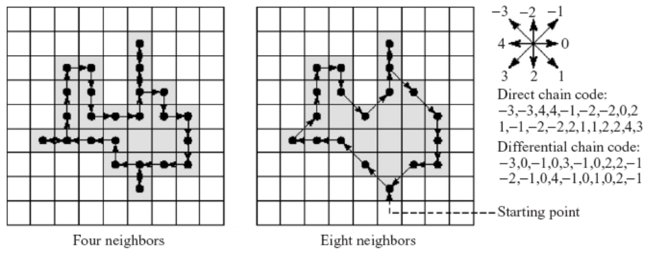
Fig. 9.5 Chain coding with four- and eight-neighbor connectedness Error: Reference source not found.

Baseline-based shape coding is another way to encode the contour of the shape. The shape is first placed into a 2D coordinate system such that the projection of the shape on to the x-axis (baseline) is longest. The algorithm then samples the shape contour in clockwise direction. The distance(y-coordinate) between the baseline and a point on the shape outline is coded differentially. Fig. 9.6 shows an example of baseline-based coding for a contour. Turning points are marked for the contour pixels where change in direction takes place.
In Error: Reference source not found, the authors compare contour-based coding schemes and find that the vertex-based shape coder outperforms the baseline coder both in terms of coding efficiency for intercoding and in terms of computational complexity.
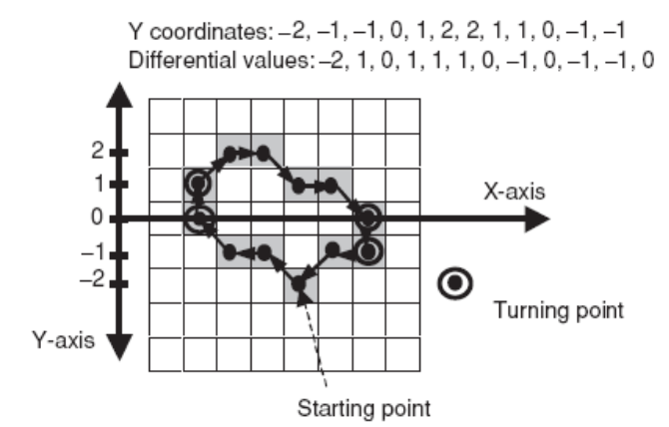
Fig. 9.6 Baseline-based shape coding Error: Reference source not found.

- Chroma key shape coding: Pixels that lie outside the VOP are assigned a chroma key which is a color not present in the VOP. The resulting sequence of frames is encoded using a standard MEPG-4 coder. This scheme is advantageous because of its low computational and algorithmic complexity for both the encoder and decoder. This technique, however, is not suitable for lossless shape coding since the shape information is carried by the typically subsampled chroma components. Chroma keying is also not as efficient as the other shape coding techniques because the decoded shape topology is not stable for complex objects. Sometimes the color of the key could bleed into the object due to quantization losses Error: Reference source not found.
The shape and transparency of VOPs can be coded using grayscale alpha map coding technique. In contrast to binary shape coding, grayscale alpha map coding has to deal with blocks of the VOP which may have different transparencies. For the case of VOPs with constant transparency, grayscale alpha map coding degenerates to binary shape coding. The only difference is that the 8 bit alpha value corresponding to the transparency of the BOP also needs to be transmitted. For VOPs with varying transparency, the algorithm encodes the outline of the shape using binary shape coding and the alpha map values are coded using padding, motion compensation, and DCT since these values are viewed as luminance values Error: Reference source not found.

Texture Coding
- Intracoding: Regular 8 by 8 DCT is performed for 8 by 8 blocks containing texture information that completely lie inside the VOP. Blocks that lie completely outside VOP are not encoded. For boundary blocks, padding technique and shape-adaptive DCT can be used.
Padding Error: Reference source not found for intracoding of boundary blocks is a quite ideal way that assigns values to the transparent pixels in an 8 by 8 boundary block without affecting the coding efficiency. Instead of assigning arbitrary values to the transparent pixels which may end up with large and high frequency DCT coefficients, the padding technique first replicates the average of all the opaque pixels in the block across the transparent pixels. A filter is then applied recursively to each of the transparent pixels in the raster scan order such that each pixel is replaced by the average of its four neighbors:
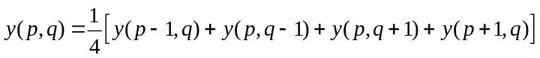.
Illustrations in Fig. 9.7 give us a better idea of this process.
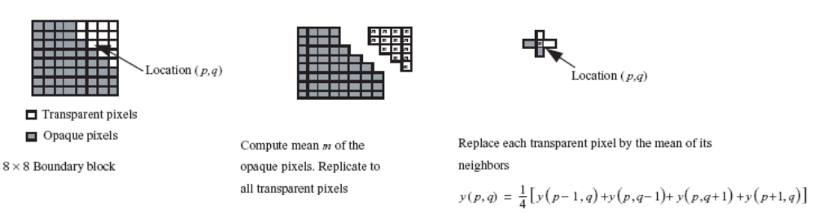
Fig. 9.7 Padding for texture coding of boundary blocks Error: Reference source not found.

Another way of coding the texture of boundary blocks is the shape adaptive DCT (SA-DCT) introduced in Error: Reference source not found. This method is based on predefined orthogonal sets of DCT basis functions and implemented with very low computational complexity [X4]. The algorithm transforms the arbitrarily-shaped image segments in horizontal and vertical directions separately. The overall process is illustrated in Fig. 9.8. The length of each column of the foreground segment is first calculated and then the columns are shifted and aligned to the upper border of the 8 by 8 reference block. A variable length (n-point) 1-D DCT transform matrix DCT-N
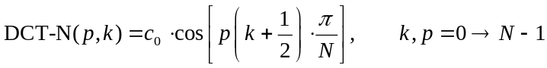
containing set of N DCT-N basis vectors is used. Note that 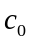 is 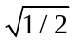 if p = 0, and = 1 otherwise. The variable p is the original pth DCT basis vector. According to the formula
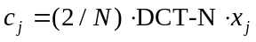
the N vertical DCT-coefficients c_{j} for each segment column data x_{j} are calculated. In Fig. 9.8(b), the opaque segments are shifted to the upper border and each column is transformed using DCT-N basis vectors. As a result DC values for the segment columns are concentrated on the upper border of the reference block as shown in Fig. 9.8(c). As depicted in Fig. 9.8(e), before the horizontal DCT transformation, the length of each row is calculated and the rows are shifted to the left border of the reference block. A horizontal DCT adapted to the size of each row is then found using (2) and (3). Finally the layout of the resulting DCT coefficients is obtained as shown in Fig. 9.8(f). All vertical DC coefficients (marked with red dots in Fig. 9.8(c)) are grouped together and transformed in horizontal direction. The resulting coefficients are located in comparable positions as in a standard 8 by 8 block Error: Reference source not found.
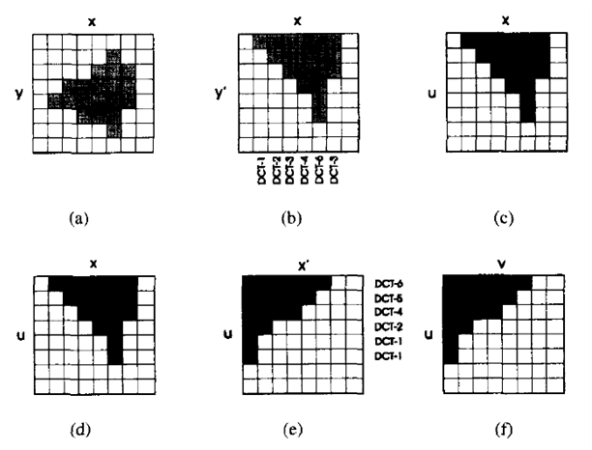
DC values
DC coefficient
Fig. 9.8 Successive steps of SA-DCT performed on an arbitrarily shaped image segment Error: Reference source not found.

After performing shape adaptive DCT, the coefficients are then quantized and encoded by methods used by the 8 by 8 2-D DCT. The decoder can perform the shape-adapted inverse DCT in both the horizontal and vertical segment direction after the contour of the shape segment is first decoded [X2].
- Intercoding: Different motion estimation and compensation schemes are used to remove temporal redundancies [X2]. Usually the typical motion compensation scheme is block-based and each macroblock is defined as a 16 by 16 pixel block. The encoder predicts a P-VOP or B-VOP from a reference I- or P-VOP using motion compensation. Note that an I-VOP is a reference VOP. In intercoding mode, a P-VOP uses one-directional inter prediction from a previously encoded I- or P-VOP. Since the offset (the motion vector) between the current macroblock and the compensation region in the reference picture may have half-pixel resolution, predicted samples at sub-pixel positions are obtained using bilinear interpolation which interpolates samples at positions between integer pixels. The predicted matching region is then subtracted from the current macroblock and a residual macroblock is produced. This residual data will be coded using normal DCT-based coding method. Motion compensation efficiency can also be improved by the B-VOP because it uses bidirectional prediction [X5]. Prediction of a macroblock can be made by one of the following methods [X5]:
- forward prediction from the previous I- or P-VOP,
- backward prediction from the next I- or P-VOP
- or an average of the forward and backward predictions
An illustration of this concept is shown in Fig. 9.9. Although this mode can further enhance coding efficiency compared to basic forward prediction, the memory requirements and the encoding delay are increased because the encoder has to store multiple frames before encoding each B-VOP.
Temporal order
I
B
B
P
Foward
Backward
Bidirectional
Fig. 9.9 Prediction modes for B-VOP [X5].

Fig. 9.10 shows a reference VOP with opaque pixels in grey and a current VOP. Both of them consist of nine macroblocks. In each of the 3 example macroblocks, some of the opaque pixels in the current macroblock are motion-compensated from transparent pixels in the reference VOP. Because the values of transparent pixels are not defined, padding transparent pixel positions in boundary and transparent macroblocks in the reference VOP is necessary. This is done by extrapolating the transparent pixels in each boundary macroblock in a reference VOP horizontally and vertically from opaque pixels [X5]. Padding is performed before estimating motion vector for boundary macroblocks [X2].
As illustrated in Fig. 9.11(a), if a row is bordered by opaque pixels at only one side (ex: 3rd and 4th row from top), the value of the nearest opaque pixel is copied to all transparent pixel positions. In the instance of a row bordered by opaque pixels on both left and right sides, the padding algorithm fills the mean value of the two neighboring opaque pixels to the transparent pixel positions. The horizontally padded result is shown in Fig. 9.11(b). Opaque pixels including those of horizontally padded are then extrapolated in vertical direction in order to fill the remaining transparent pixel positions. Similar to the horizontal padding, opaque pixels with one opaque neighbor are filled with the value of that pixel and columns with two opaque neighbors are filled with the mean value of the opaque pixels at the top and bottom of the column. We also need to fill transparent macroblocks with padded pixel values because they may fall partly or wholly within a motion-compensated reference region (e.g. the reference region for MB3 in Fig. 9.10) [X5]. Generally this padding extrapolates the VOP pixels outside the macroblock’s own bounding window for unrestricted motion vector search. Detailed padding rules for transparent macroblocks are given in [X5].
After padding of the reference BOP, a polygonal shape matching technique is performed to find the best match for the boundary macroblock. A polygon is used to define the part of the boundary macro block that like inside VOP, and when block matching is performed, only pixels within this polygon are considered [X2].
Reference area for MB2
Reference area for MB1
Reference area for MB3
MB2
MB1
MB3
Reference VOP
Current VOP
Fig. 9.10 Examples of reference areas containing transparent pixels [X5].
Horizontal padding
After horizontal padding
Vertical padding
Fig. 9.11 Horizontal and vertical padding in boundary MB [X5].

Sprite Coding
A sprite Error: Reference source not foundError: Reference source not found refers to an image describing a panoramic background view of a video sequence and it may be much larger than the visible area of the scene. In order to generate sprite images, the video sequence is partitioned into a set of subsequences with similar content. Different backgrounds are generated for different subsequence. As illustrated in Fig. 9.12, the background object is segmented in each actual frame of the subsequence and warped to a fixed sprite coordinate system after estimating its motion. The warping process is concerned with the application of an affine transformation to the background object. The warped background images obtained from the frames in the subsequence are eventually combined into the background sprite image using median filtering or averaging operations. An example of sequence of frames and the resulting background sprite are shown in Fig. 9.13 and Fig. 9.14 respectively.
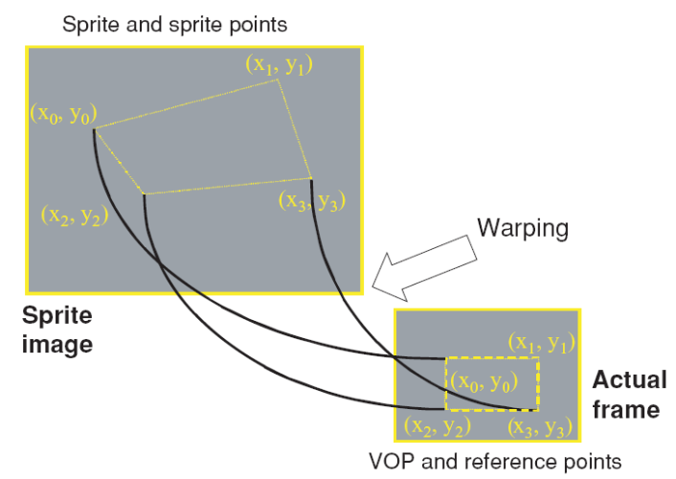
Fig. 9.12 Warping of the sprite to reconstruct the background object Error: Reference source not found.

Fig. 9.13 Sequence of frames

Fig. 9.14 Static background sprite

Since sprite images can provide a concise representation of the background, they can be used for the reconstruction or for the predictive coding of background object. MPEG-4 allows the reconstruction of the background objects form the sprite image using the inverse of the warping process and some global motion parameters. MPEG-4 supports two sprite coding modes: static sprite coding and dynamic sprite coding. In static sprite coding, the sprite is encoded before performing encoding and transmitted to the decoder as the first frame of the sequence while the moving foreground object is transmitted separately as an arbitrary-shaped video object. At the decoder side, the decoded foreground and background objects are reconstructed into a frame in the sequence. An example is shown in Fig. 9.15. A low-latency mode is also supported by MPEG-4; it is possible to transmit the sprite in multiple smaller pieces over consecutive frames and the sprite can be built up at the decoder progressively. By this method, we can avoid transmitting very large static sprite images as the first frame and thus we can avoid delay Error: Reference source not foundError: Reference source not found.

Decoded foreground
VOP
Sprite image
+

Reconstructed frame
Fig. 9.15 Combining decoded background object (from warped sprite) and foreground to obtain decoded frame.

Unlike static sprite, dynamic sprites are calculated on the fly using global motion compensation (GMC). The sprite is updated by blending from the reconstructed image and this avoids the overhead of transmitting a large sprite image at the beginning of the sequence transmission. This, however, can lead to higher decoder complexity because the updating of the sprite needs to be performed at the decoder at every time step Error: Reference source not found.

Shape Extraction and Segmentation
Some insights on shape extraction and segmentation are provided in this section. The information covered in this section is not necessary included in the MPEG-4 standard, but it is worthwhile for readers to know this information.
Simplification, feature extraction, and decision are three main steps of the typical segmentation process Error: Reference source not found. Details of each step are shown in Fig. 9.16. Simplification basically removes complex and irrelevant information from the content and produces data that can be much easily segmented. Once the content to be processed is simplified, features such as those listed in Fig. 9.16 can be extracted. These features are extracted according to the homogeneity expected within the partitions. This step is followed by a final decision stage that analyzes the feature space and partition the data into areas with distinct characteristics.
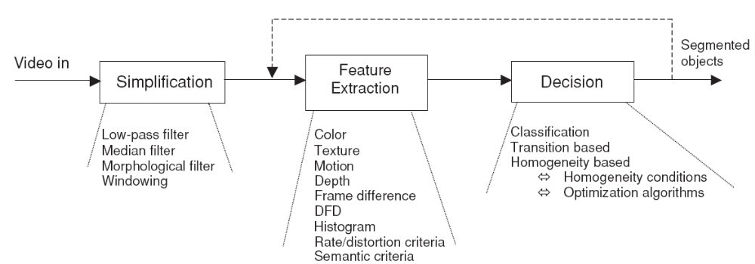
Fig. 9.16 Steps of the typical segmentation process Error: Reference source not found.

Coding of Objects with Arbitrary Shapes
Scalability in video data encoding allows a decoder to decode the selected part of the coded bitstream and it is especially needed for video transmission over low bit-rate wireless networks or the internet Error: Reference source not foundError: Reference source not found. Normally the coded bitstream is sorted into different layers which include a base layer and other enhancement layers. A basic concept of scalability is provided in Fig. 9.17. Decoder A only receives base layer as input and decodes low quality version of the video scene while decoder B receives all layers and produces high quality version of the video scene. This unique coding concept is very useful if we only have a low-complexity decoder or a network with limited transmission capacity Error: Reference source not found.
Enhancement layer N
encoder
Video
sequence
Enhancement layer1
……
Decoder A
Base layer
Decoder B
Basic-quality sequence
High-quality sequence
Fig. 9.17 General concept of scalability Error: Reference source not found.

MPEG-4 contains 4 scalable coding modes and these modes are discussed in the following sub-sections.

Spatial Scalability
Spatial scalability allows us to code a VOP at a hierarchy of spatial resolutions. In this case, the base layer is composed by a reduced-resolution version of each coded frame. A low resolution version of the VOP can be produced by decoding the base layer alone. If we decode the base layer with enhancement layer, we can obtain an output with higher resolution. An example of a two-layer coder is demonstrated in the following steps:
- Subsample each input video frame in both horizontal and vertical directions.
- Encode the subsampled (resolution-reduced) frame to form the base layer.
- Decode the base layer and upsample to the original resolution to form a prediction frame.
- Subtract the full-resolution frame (the original frame) from this prediction frame to form the residual.
- Encode the difference (residual) as the enhancement layer.
The two-layer decoder in this example can reconstruct a full-resolution sequence by decoding both the base layer and enhancement layer and up-sampling the base layer to the original resolution. A full resolution sequence can then be obtained by adding the decoded residual from the enhancement layer to the decoded base layer.

Temporal Scalability
In temporal scalable coding, the base layer of a temporal scalable sequence that is encoded at a low video frame rate and temporal enhancement layer can be decoded together to build up higher video frame rate.

Object-Based Scalability
In MPEG-4, the ability to selectively decode and reconstruct particular video content of interest is enabled. In fact, relevant objects within the video can be enhanced in terms of their quality, spatial resolution or temporal resolution.

Fine Granular Scalability
Fine granular scalability (FGS) allows the enhancement layer to be truncated during or after decoding such that highly flexible control over the transmission bitrate can be achieved. This method is especially useful for video streaming applications over IP because the available bandwidth may be unknown. Normally a sequence is coded as a base layer and a high-quality enhancement layer. The amount of truncation in the enhancement layer is determined in order to match the available bitrate. This maximizes the quality of the decoded sequence Error: Reference source not found. The FGS encoding frame-work is shown in Fig. 9.18. This framework consists of two encoders: base layer encoder and enhancement layer encoder. In the enhancement layer encoder, residual DCT coefficients are first obtained by subtracting the de-quantized DCT coefficients of the base layer from the DCT coefficients of the original motion compensated frames.
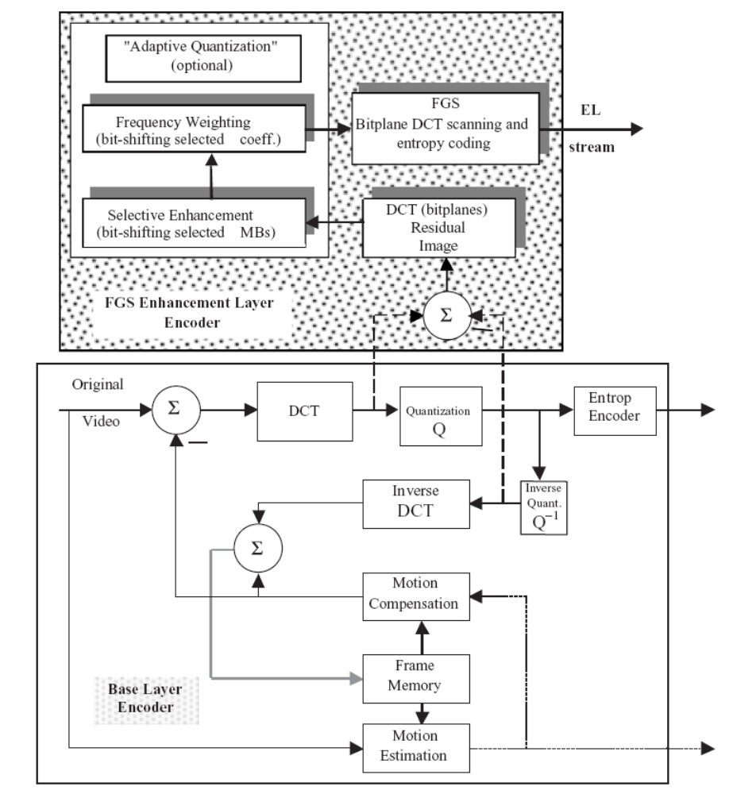
Fig. 9.18 The encoding process of the base layer and enhancement layer Error: Reference source not found.

These resulting residual coefficients are then coded bitplane by bitplane Error: Reference source not found.
Each DCT FGS-residual frame contains 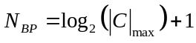 bitplanes and  represents the maximum DCT value of the residual coefficients. The FGS enhancement layer encoder scans the residual frame macroblock by macroblock using the traditional zig-zag scanning method. The reordered coefficients are then entropy coded. Note that each macroblock includes four 8 by 8 luminance (Y) blocks and two chroma blocks (U and V). The number of bitplane corresponds to the bit in location B, which is counted from the least significant bit (LSB) to the most significant bit (MSB), in the binary representation of the coefficient magnitude. For instance, if the encoder is scanning bitplane 3, a coefficient with magnitude 12(1100) will have corresponding value 1 while a coefficient with magnitude 11(1011) will have corresponding value 0. These zero and one sequences are then entropy-coded using run-length codes and the FGS-compressed bitstream is produced Error: Reference source not found.
At the decoding side, the FGS bitstream is fed into a variable length decoder (VLD) to regenerate DCT residual bitplanes starting from the most significant bitplane to the least significant bitplane. Note that the basic SNR FGS codec employs embedded DCT variable length coding. Bit-plane de-shifting is included to compensate for the two “adaptive quantization mechanism: selective enhancement and frequency weighting. Finally the DCT residual is inverse-transformed to generate the SNR residual pixels which are added to the base-layer decoder output to produce the final enhanced scalable video Error: Reference source not found.
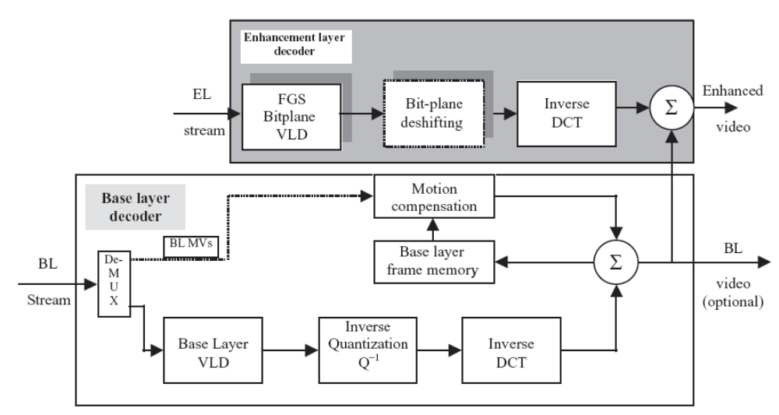
Fig. 9.19 FGS SNR decoder Error: Reference source not found.

Adaptive quantization can be used to improve the visual quality of transform-coded video. It is a process that employs different quantization step sizes for the different transform coefficients in a block. Adaptive quantization used in FGS coding is a process of bitplane shifting which is equivalent to multiplying a particular set of coefficients to selected macro blocks of an FGS enhancement layer frame or selected coefficients in the 8 by 8 blocks by an integer that is a power of two. A particular macroblock k that needs to be emphasized within an FGS frame is selected and all blocks within the selected macroblock k are multiplied by a factor 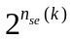. The resulting new value 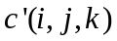 of a coefficient i of block j can be expressed as
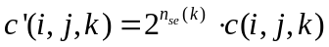
where 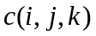is the original value of the coefficient. The operation in is equivalent to up-shifting the original set of coefficient by 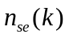bitplanes relative to other coefficients that belong to other macroblocks. This approach that is used to enhance selected macroblocks within a given frame relative to other macroblocks within the same frame is called Selective Enhancement which is illustrated in Fig. 9.20. As a result, each up-shifting operation produces an additional bitplane.
FGS also allows bitplane shifting of selected DCT coefficients. A frequency weighting matrix can be defined and each element of the matrix represents the number of bitplanes 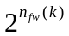that the ith coefficient should be shifted by. Similar to the selective enhancement case, we can represent the new coefficients by
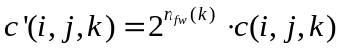
An example of frequency weighting is shown in Fig. 9.21. Usually both selective enhancement and frequency weighting techniques are used together and in this case, the values of the resulting coefficients can be expressed as
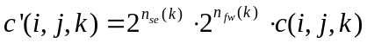
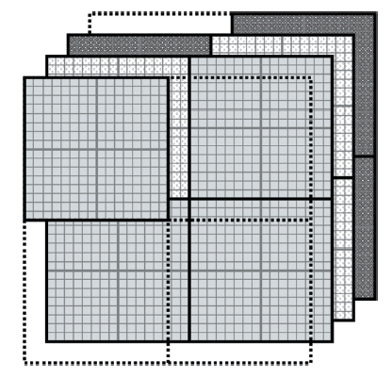
Fig. 9.20 The use of the selective enhancement Error: Reference source not found.

In Fig. 9.22, two new bitplanes are produced because each of both selective enhancement and frequency weighting is used once. Originally, there are only 3 bitplanes and the frame is divided into four macroblocks. Then a new bitplane is generated by performing selective enhancement (up-shifting) to the uppoer-left macroblock. Next, an additional bitplane is generated by performing frequency-weighting technique (one-bit-plane shifting) to the 4 by 4 lowest-frequency DCT coefficients. Note that this is applied to all macroblocks in the FGS frame as shown in Fig. 9.22. The difference is that selective enhancement is employed on a macroblock-by-macroblock basis and the frequency weighting matrix can be applied to all macroblocks in the FGS frame.

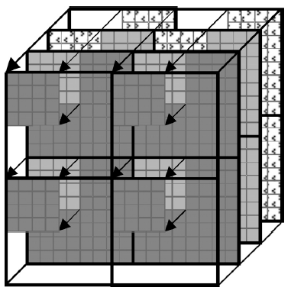
Fig. 9.21 FGS frequency weighting Error: Reference source not found.

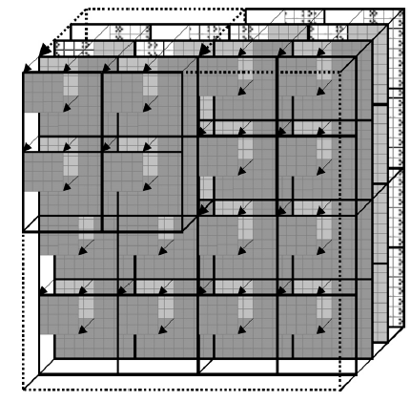
Fig. 9.22 An example showing the use of both selective enhancement and frequency weighting Error: Reference source not found.

